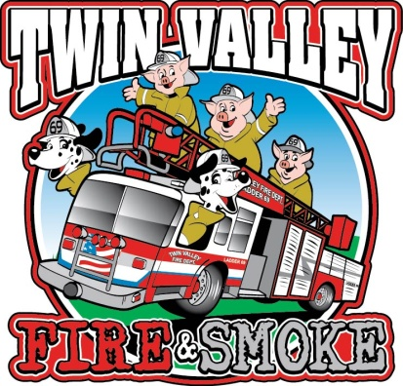
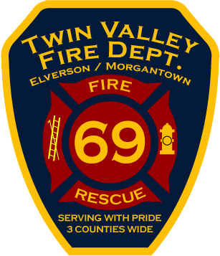
Publicly
Judged
First
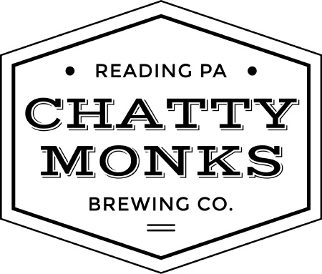
Responder
Wing
Contest
Friday May 18th 2018
Judging starts at 6:00 PM

Located at
Friendship Park
3287 N Street, Morgantown, PA 19543
